BALLYMAHON MUNICIPAL DISTRICT

Corporate Affairs,
Aras an Chontae,
LONGFOIRT.

16th March 2016.

Please note Venue of Meeting – St. Dominic’s Community Centre, Kenagh

To: Each Member of Ballymahon Municipal District.

Dear Member,

You are requested to attend Meeting of Ballymahon Municipal District to be held in St. Dominic’s Community Centre, Kenagh on Thursday, 24th March 2016 at
4.00 p.m. to transact business, as set out on the Agenda hereunder.

Yours sincerely,
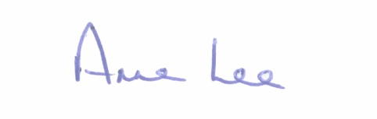

_______________
Anne Lee,
Meetings Administrator.

AGENDA

Prayer before meeting.

1. Confirmation of Minutes of the Ballymahon Municipal District Meetings held on the 28th January and 25th February 2016 - copies enclosed.

2. Matters arising from Minutes.

3. Fix date for Annual Meeting of Ballymahon Municipal District.

4. Consideration and adoption of Draft Municipal District Report for inclusion in Longford County Council 2015 Annual report – draft enclosed.

5. Casual Trading in Ballymahon.

6. Update on parking Bye-Laws in Ballymahon.

7. Update on defective manhole in Lanesboro.

8. A.O.B.

